**NRT NO:15118**

**N.R.T - One tap auto google sign up to be implemented with Tracking**

1. Refer <https://developers.google.com/identity/one-tap/web/guides/get-google-api-clientid> for step by step implementation for google signup
2. This feature is implemented on both desktop and mdot
3. Tracking for this is also implemented in which how many users have signup and login through gmail account
4. Pop up comes only if the user has logged into gmail account and not logged in to MS account.

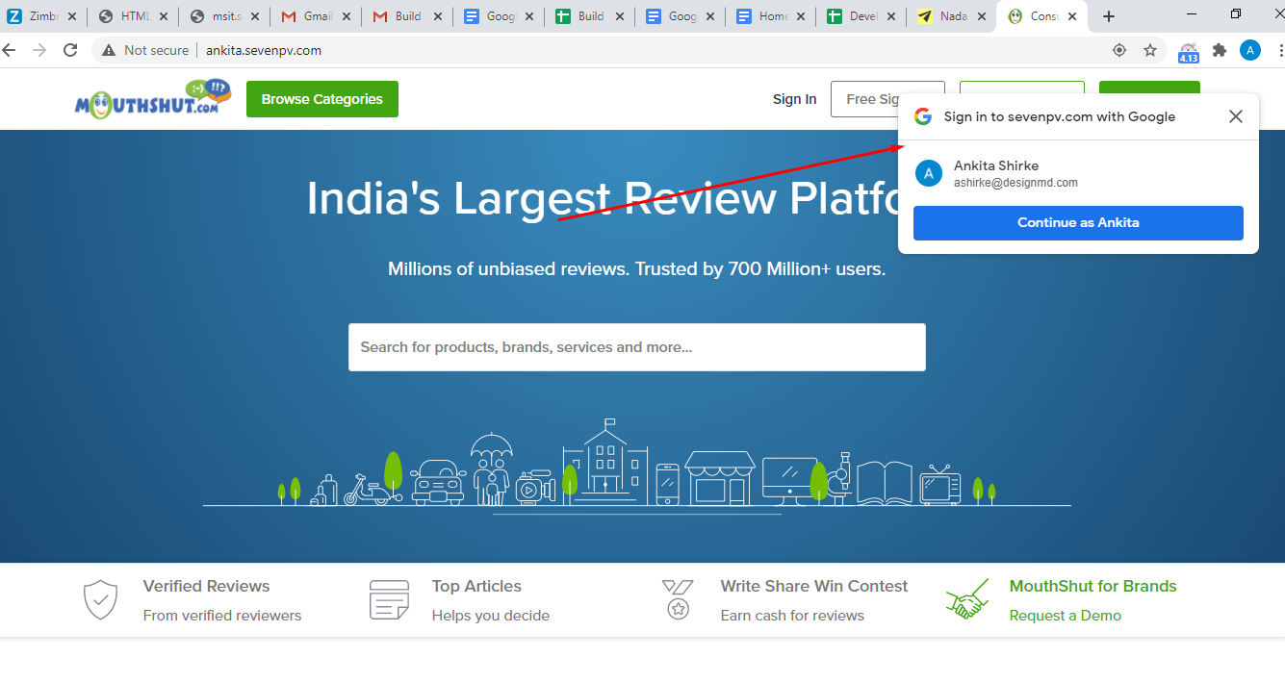

Code:

UI\INCLUDES\MASTER\HeaderFooter_MS.master

UI\INCLUDES\MASTER\HeaderFooter_New.master

**<script src="https://accounts.google.com/gsi/client" async defer></script>**

**The above <script> tag is used to load one tap client library**

When User is not logged in that time user will get popup of one tap for login through google

<% If Session("id") = 0 Then%>

<script src="https://accounts.google.com/gsi/client" async defer></script>

**To display google one tap use below code**

<div id="g_id_onload"

data-client_id="<%=ConfigurationManager.AppSettings("googleConsumerKey")%>"

data-login_uri="<%=mshost%>/facebooklogin/Data_login_uri.aspx"

<%-- data-login_uri="https://ankita.sevenpv.com/facebooklogin/GoogleLogin.aspx?l=1&host=web"--%>

data-your_own_param_1_to_login=""

data-your_own_param_2_to_login="" data-cancel_on_tap_outside="false">

</div>

<% End If%>

**Tracking**

Ms_onetap_login table is created for tracking purpose

Flag column in above table

For existing user E is used

For new user N is used

**Admin Page**

<https://ankita.sevenpv.com/admin/AutoContestDataManagement.aspx>

**Procedure:**

$/MS11.0 - HTTPS/DATABASE/9.0/Stored Procedures/FetchAutoContestData.sql

@Type =6--for one tap tracking

See to it below settings are enable for incognito [popup not displayed, to display follow below settings]

